Safeguarding Code Application Step by Step

21 June 2020
Version 1.4

Author:

Matthew Taylor
matt.sensei@teyfordkarate.club
Tel: +44 1189706943

Revision History

Version | Date | Author | Comments / Sections Updated
1.0 | 05/08/20 | Matthew Taylor | Initial release
1.1 | 09/09/20 | Matthew Taylor | Links to documents added
1.2 | 21/06/21 | Sue Harrison | Changes due to website update
1.3 | 21/06/21 | Matthew Taylor | DBS application link added
1.4 | 30/05/25 | Matthew Taylor | Updated DBS application info

Table of Contents
1 Introduction 3
1.1 The Purpose of this Document 3
2 What you will need 4
2.1 Getting your Public Liability Insurance 4
2.2 Getting your DBS Certificate 4
3 Your Safeguarding Code Application 5
3.1 Register your Club 5
3.2 Start your Application 5
3.2.1 Getting Started 7
3.2.2 Policies 7
3.2.3 Procedures 10
3.2.4 Practices 11
3.2.5 Education and Training 11
3.2.6 Implementing and Monitoring 11
3.3 Submitting your Completed Application 12

Introduction
The Safeguarding Code in Martial Arts recognises clubs or providers in England who have demonstrated that they have reached and maintained good safeguarding standards.

An application to register your club with the Safeguarding Code in Martial Arts can be made by creating an account on the https://www.safeguardingcode.com website and completing the application process.

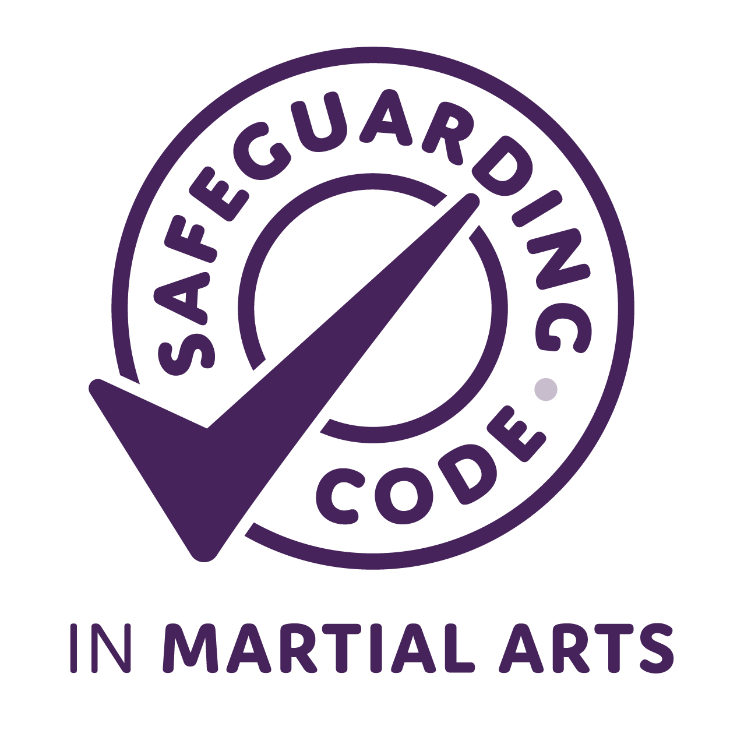
Once your application has been accepted you will be able to use the Safeguarding Code “mark” and have your club listed in their club finder feature.

If you have any problems with your application please contact Sue.harrison@educare.co.uk
Tel. 07931 365956

The Purpose of this Document
This document will act as a guide for completing the Safeguarding Code application process by listing the resources you will need and the steps required.

What you will need
✔ You will need to download the following documents from the safeguarding page of the GKI website:

- GKI Safeguarding Policy – Children
- GKI Safeguarding Policy – Adults
- GKI Safeguarding Statement
- GKI Safeguarding Contacts
- GKI Safe Practice Policy
- Risk Assessment Template

✔ You will need to have your Public Liability Insurance in place.
✔ You will need to have an up to date DBS certificate.
✔ You will need to have a designated Safeguarding/Welfare Officer that has attended face to face training in the last three years, a photo of them and their address for use on your website or social media.
If you are a small individual club you may use the details on the safeguarding page of the GKI website.

Getting your Public Liability Insurance
Use your website browser to search for ‘Martial Arts Insurance’ and select a company specialising in it for a quotation.

Here are some companies used by the GKI instructors:

- Martial Guard
- Insure4Sports

Getting your DBS Certificate
The service below can be used if your Dojo is not linked to a local council:

You will require an enhanced DBS and the procedure for applying for this can be found in the following document on the safeguarding page of the GKI website:

- DBS Application & Safeguarding Training

Your Safeguarding Code Application

Register your Club
Follow the list of steps to register on the Safeguarding Code website:

- Goto www.safeguardingcode.com in your website browser.
- Click on ‘LOGIN/REGISTER TO GET STARTED’.
- Click on ‘Create new account’.
- Fill out all the details on the registration form:
  - For the ‘Governing Body or Franchise+’ field select ‘Other’.
  - For the ‘If other or franchise please state+’ field enter ‘Goju Ryu Karate Do International’.
  - Tick the box for the field ‘Is this the main admin account that will complete the Safeguarding Code for your organisation?’.

- Click the ‘Create my New Account’ button.
- You should receive an email confirming your registration. This should not take long and remember to look in your spam folder.

Start your Application
Your application is saved as you go along so it can be done in stages and does not have to be done all at once.
Follow the list of steps to start your application:

- Goto www.safeguardingcode.com in your website browser and Click on ‘LOGIN/REGISTER TO GET STARTED’.
- Enter your username and password and click the ‘Log in’ button and you should see the following page:

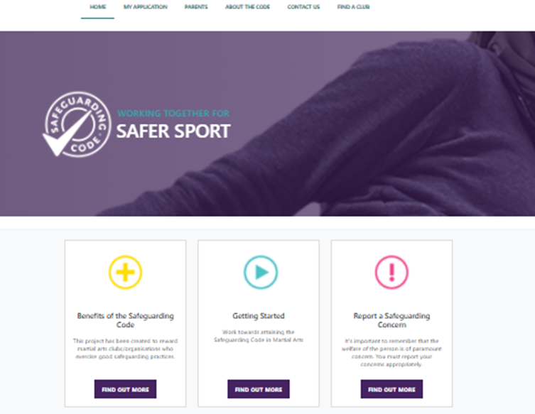

- Click the ‘MY APPLICATION’ main menu option.

- You should see the following page:
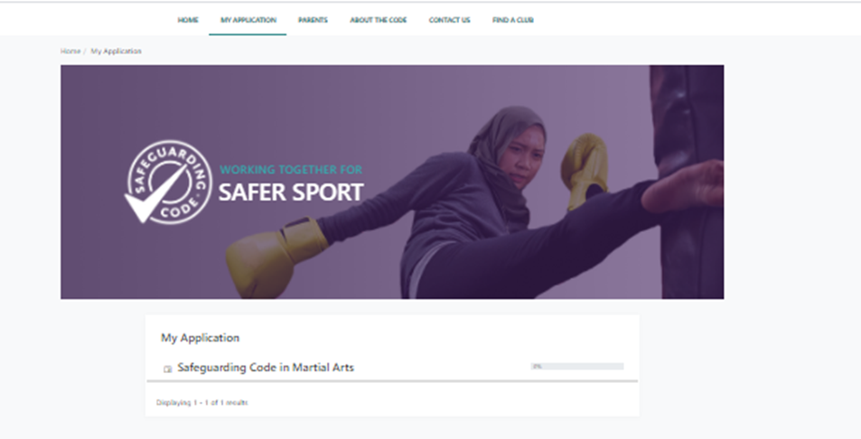
- Click on ‘Safeguarding Code in Martial Arts’.
- You will then see this menu list which is the start of the application process:

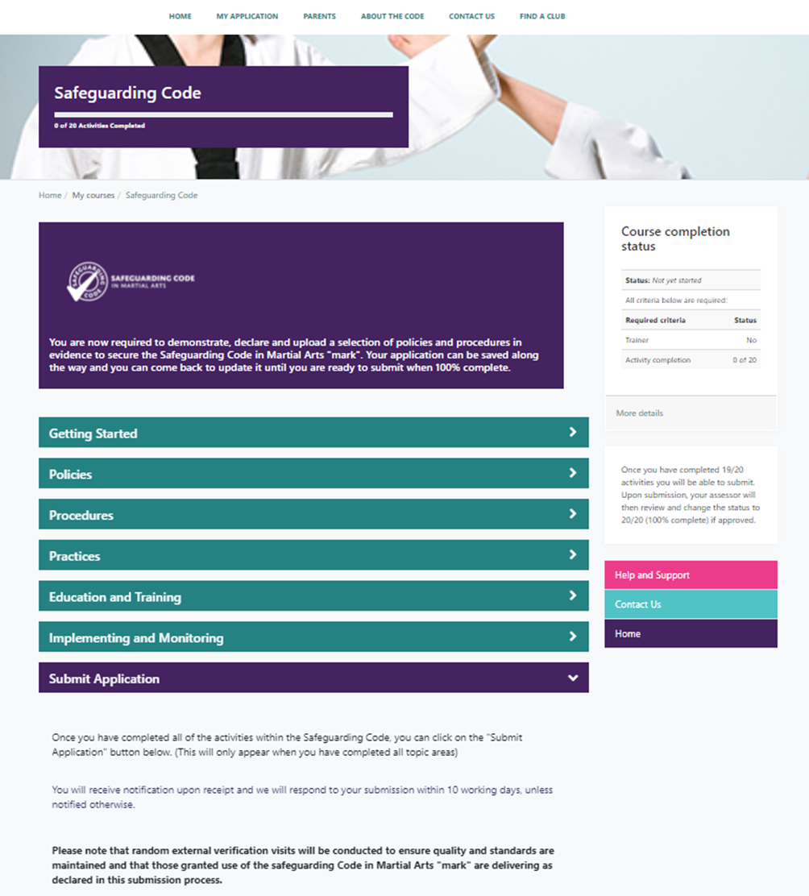

Getting Started
- The ‘Getting Started’ section can be ignored if you are using this guide.

Policies
- Click the ‘Policies’ section to expand it.
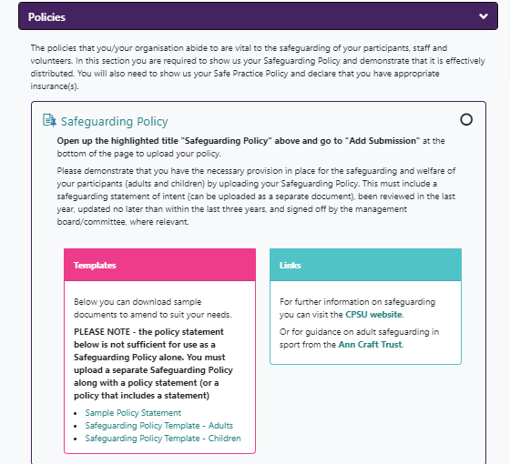
- Click ‘Safeguarding Policy’ at the top of the first box.
- You will see the following screen:
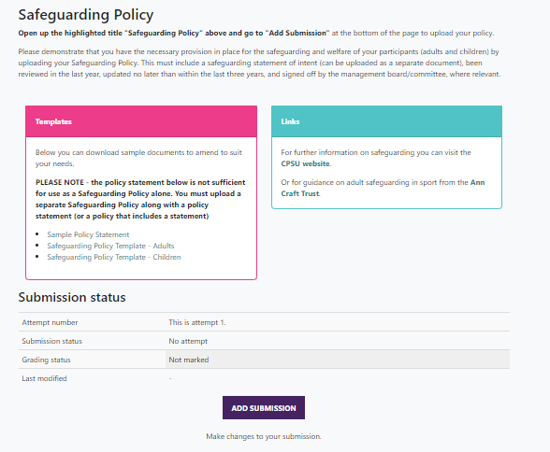
- Click the ‘Add submission’ button.
- Drag the following documents that you saved from the safeguarding page of the GKI website into the file submissions box:
  - GKI Safeguarding Policy – Children
  - GKI Safeguarding Policy – Adults
  - GKI Safeguarding Statement
  - GKI Safeguarding Contacts

- Click the ‘Save changes’ button.
- Click the ‘Back’ button at the top of the page to return to the main application menu.
- Scroll to the ‘Safeguarding Policy Awareness’ section and tick the box on the right hand side to say that you are aware of the police in the GKI Safeguarding Statement.
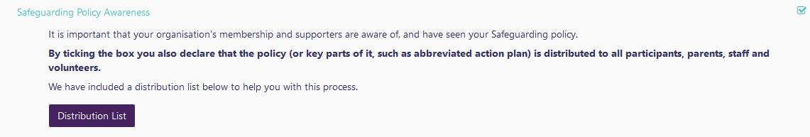

- Scroll down and click ‘Safe Practice Policy’.
- Click the ‘Upload your Document’ button.
- Ensure that you tick the following box:
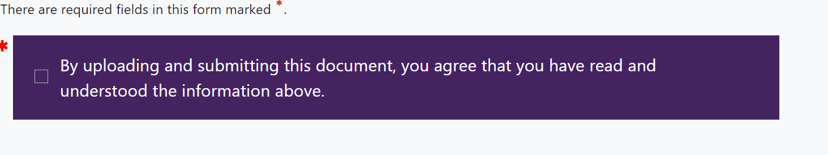
- Scroll down and drag the following documents that you saved from the safeguarding page of the GKI website into the file submissions box:
  - GKI Safe Practice Policy

- Click the ‘Save changes’ button.
- Click the ‘Back’ button at the top of the page to return to the main application menu.
- Scroll down to the ‘Insurance’ section. Read the declaration and if you have the required insurance in place tick the box on the right hand side.
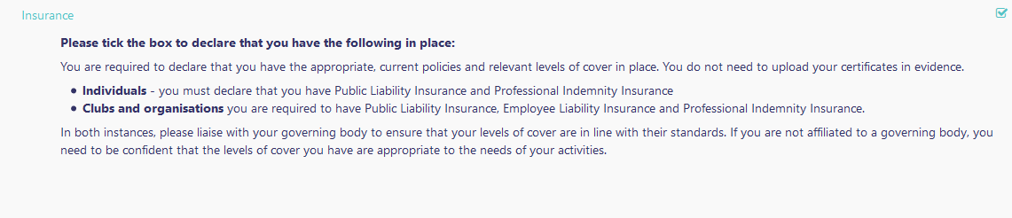

Procedures
- Click the ‘Procedures’ section to expand it.
- Read the declarations for each of the following sections and tick the boxes on the right hand side to confirm that you have them in place and are following them:
  - Reporting Concerns (GKI Safeguarding Statement document on the safeguarding page of the GKI website)
  - Designated Welfare/Safeguarding Officer (Internal Contact) (GKI Safeguarding Contacts document on the safeguarding page of the GKI website)
  - Designated Safeguarding Person (External Contact) (GKI Safeguarding Contacts document on the safeguarding page of the GKI website)
  - Complaints Procedure (Complaints Procedure document on the safeguarding page of the GKI website)
  - DBS Checks and Safe Recruitment (GKI Safeguarding Statement document on the safeguarding page of the GKI website)

- Scroll down and click ‘Individual Statement’.
- One the next page click ‘Answer the questions...’
- Answer the questions and click the ‘Submit your answers’ button.
- Click the ‘Continue’ button.

Practices
- Click the ‘Practices’ section to expand it.
- Read the declarations for each of the following sections and tick the boxes on the right hand side to confirm that you have them in place and are following them:
  - Codes of Conduct (Codes of Conduct for children, parents & staff documents on the safeguarding page of the GKI website)
  - Practical Guidance (GKI Safeguarding Statement document on the safeguarding page of the GKI website)
  - Sources of Help (Sources of Help document on the safeguarding page of the GKI website)
  - Complaints Procedure (Complaints Procedure document on the safeguarding page of the GKI website)
  - DBS Checks and Safe Recruitment (GKI Safeguarding Statement document on the safeguarding page of the GKI website)

Education and Training
- Scroll down and click the ‘Education and Training’ section to expand it.
- Read the declaration for ‘Safeguarding Training’ and tick the box.
- Click on ‘Recognised Qualifications’.
- Click the ‘Add submission’ button.
- Paste in your instructor’s bio and click the ‘Save changes’ button.
- Scroll to the top and tick ‘I have completed this activity’.
- Click the ‘Back’ button at the top of the page to return to the main application menu.
- If you have received any specialist training e.g. disability coaching then click on ‘Specialist Training’ and follow this list:
  - Click the ‘Add submission’ button.
  - Enter the details of your training and click the ‘Save changes’ button.
  - Scroll to the top and tick ‘I have completed this activity’.
  - Click the ‘Back’ button at the top of the page to return to the main application menu.

If not relevant, please write “Not Applicable” and click the ‘Save changes’ button.

- Click on ‘Refresher Training’.
- Click the ‘Add submission’ button.
- Enter the details of your process for ensuring you are kept up to date on safeguarding. e.g. “I have a calendar reminder set to tell me when to schedule an on-line refresher course or face to face course with an appropriate safeguarding course supplier.”
- Scroll to the top and tick ‘I have completed this activity’.
- Click the ‘Back’ button at the top of the page to return to the main application menu.

Implementing and Monitoring
- Scroll down and click the ‘Implementing and Monitoring’ section to expand it.
- Click on ‘Policies and Procedures’.
- Click the ‘Add submission’ button.
- Enter the details of how you ensure your DBS is kept up to date yearly and click the ‘Save changes’ button.
- Scroll to the top and tick ‘I have completed this activity’.
- Click the ‘Back’ button at the top of the page to return to the main application menu.
- Read the declaration for ‘Risk Assessments’ and tick the box.

Submitting your Completed Application
If you have completed all the steps correctly the Application progress table will show ‘Course completion status 19 of 20’.

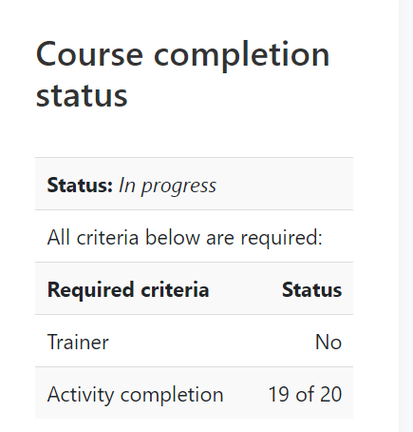

If this is not the case then review the sections to see which boxes are unticked.

- Scroll down and click the ‘Submit Application’ section to expand it.
- Click the ‘Submit Application’ button.
- Enter your name and role into the text box and click the ‘Save changes’ button.
- Your application will be submitted and the current status displayed.

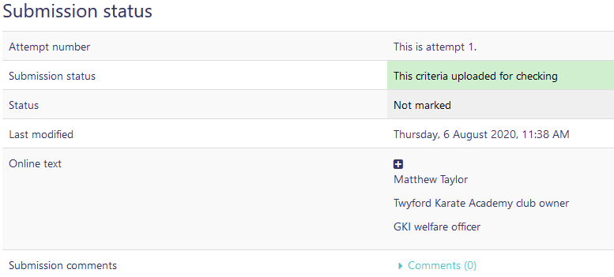
It may take up to 10 days to process your application.

